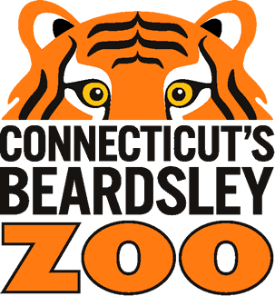
Digital Wild Adventure Request Form
Connecticut’s Beardsley Zoo
Education Department
1875 Noble Avenue
Bridgeport, CT 06610-1600

Please return this form to the Zoo’s Education Department to request your Digital Wild Adventure
You should receive an invoice / confirmation within 2 weeks

Phone: (203) 394-6563 Email form to: programming@beardsleyzoo.org

Name of Group: | Description (Public School, Assisted Living, etc.):
Street Address: | City: | State and Zip Code:
Contact Name: | E-mail Address:
Phone Number: | Alternate Phone:

Grade / Age of students: | Number of students: |  | Number of adults: |  | Desired Program Time(s):
Program date (1st choice): |  | Program date (2nd choice): |  | Program date (3rd choice):

Wild Adventure Options:  (Choose Option A or B, and additional offerings if desired)  - 2 x 2 ($250)  - 2 Animal Ambassadors  - 2 Animal Habitats/Locations Around Zoo  - 3 x 3 ($300)  - 3 Animal Ambassadors  - 3 Animal Habitats/Locations Around Zoo | Additions:  - Bobcat Training ($60)  - Commissary (Animal Kitchen) Tour ($30)

Digital Wild Adventure Request Form
Connecticut’s Beardsley Zoo
Education Department
1875 Noble Avenue
Bridgeport, CT 06610-1600

Which Livestream platform do you use?

☐ Zoom ☐ GoogleMeet ☐ Webex ☐ Other: ________________
If you use Zoom, would you like the Zoo to host the meeting?

☐ Yes ☐ No

**NOTE: If No, the lead teacher is responsible for creating, sending, and spotlighting the Zoom meeting/class they wish the Zoo to join.

Optional: Do students/your group have specific questions before the program you wish to be answered or discussed?

- Send them to: programming@beardsleyzoo.org
- Title the attachment as: “StudentQuestions-Name of School/Group”

Payment Method: Check Box

Credit/Debit | Check | Other (Write in)

